Results
It is necessary for our experiment to establish a calibration by determining the relationship between trypan blue concentration and corresponding absorbance at 630 nm. That is what we did in procedure 1. According to the Beer-Lambert’s law, the absorbance and concentration should be directly proportional^{[1]}, so we analyzed the data with MATLAB:
Table 1: Absorbance of trypan blue in different concentration
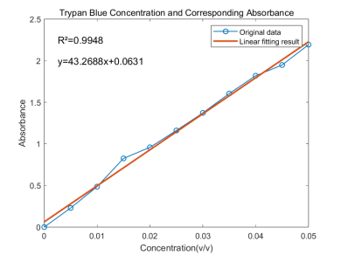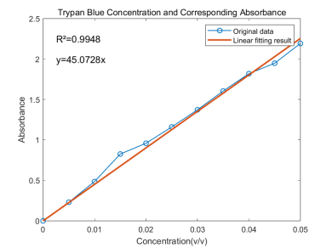
Figure 1: Absorbance of trypan blue in different concentration
The fitted calibration line should theoretically pass through the origin, so we have the slope=45.0728, which indicates that concentration=absorbance/45.0728. Also, the R² of the line is 0.9948, that shows our fitting is reliable.
Next, we prepared the solutions. The solution we used for beads is 4% trypan blue(v/v) mixed with 2% alginate solution. The solution we used for capsules is 10% trypan blue(v/v), 5% Dextran(w/v, g/ml), mixed with 4% CaCl₂ solution.
Before measuring dye release (Procedure 5), some parameters used for the production of the beads/capsules are necessary. The key parameters, as determined in the previous procedures (Procedures 3 and 4), include the bead size, the capsule wall thickness, and the quantity of beads/capsules.
In procedure 3 and 4, we created beads and capsules under a range of conditions. We considered the needle diameter, needle height, dropping speed, alginate concentration, CaCl₂ concentration and obtained following results:
• Needle Diameter: Directly correlated with the final bead size.
• Needle Height: Primarily affected the sphericity and shape uniformity of the beads.
• Solution Concentration: Higher concentrations led to faster gelation but also increased bead buoyancy, at times preventing them from submerging. During making capsules, dextran plays a significant role. The dextran helps to stabilize the structure of the capsule and form a spherical shape.
Our primary focus was on the effect of needle diameter. The bigger the diameter, the bigger the beads/capsules.
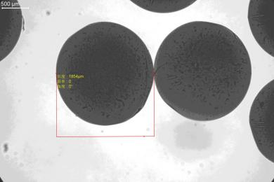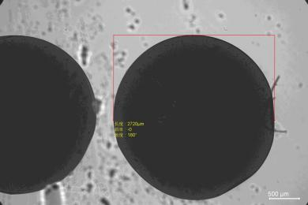
(a) (b)
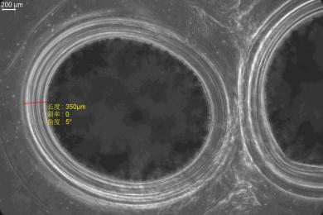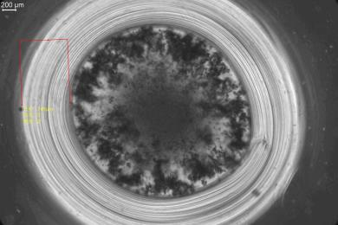
(c) (d)
Figure 2: The different diameter of beads/capsules.
(a) bead #4.5, (b) bead #12, (c) capsule #4.5, (d) capsule #6
We analyzed
******************分布分析
We also analyzed the wall thickness of capsules. The thickness is significantly influenced by immerse duration. The shell thickness was positively correlated with increased immersion time.

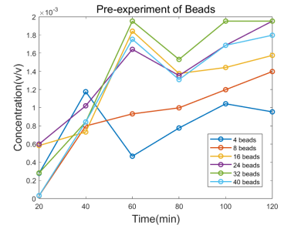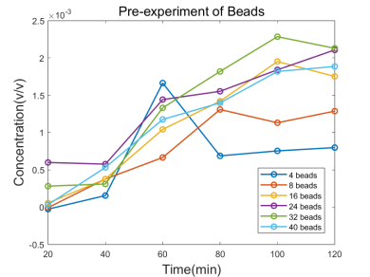
Figure 3: Release curve of beads in different sizes and quantities
The figure shows the changes in release concentration of beads over time. In figure, left plot represents for beads made by #4.5 needle and right plot represents for beads made by #6 needle. We found that the #4.5 needle and 32 beads in one well has a best release curve which looks like a first-order curve.
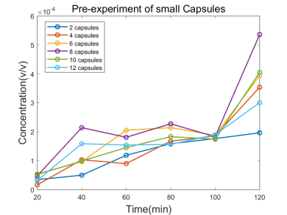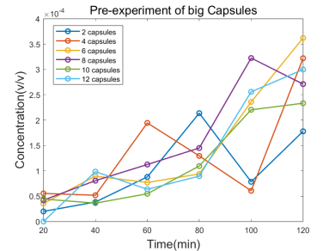
Figure 4: Release curve of capsules in different sizes and quantities
The figure shows the changes in release concentration of capsules over time. Smaller capsules are made with #4.5 needle and bigger capsules are made with #6 capsules. The bigger capsules and 6 capsules in one well has enough release concentration and looks like a zero-order curve.

To quantify the kinetics of dye release from alginate beads and capsules, we designed the following experiment.
To understand the diffusion-controlled release mechanism, we evaluated the release curves of the beads and capsules by applying established kinetic models such as zero-order and first-order release.
The parameters of beads we used for procedure 5 is the small-size (from 26G needle and 7cm height) bead and 32 in one well. The parameters of capsules we used for procedure 5 is the middle-size(23G needle from 5cm height) capsule and 6 in one well. Experimental methodology is in part “METHOD”, outcome parameters are measured by MATLAB.
Table 2: Release concentration of trypan blue over time
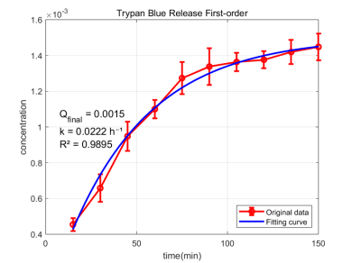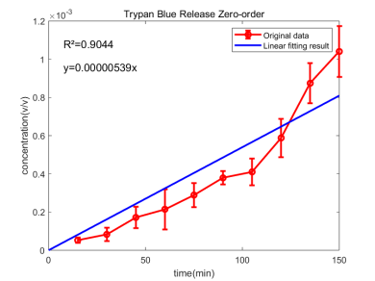
Figure 5: Release concentration of trypan blue over time

From the beads data, we observed a first-order release, so we fitted a first-order release curve in the form
$$Q=Q_{final}∗(1−e^{−kt})$$
We fitted the coefficient with MATLAB. $Q_{final}=0.0015(v/v)$ and $k=0.0222h^{−1}$. An R²value of 0.9895 confirms the success of our fitting procedure and the validity of our fitting model. As a result, the final equation is
$$Q=0.0015∗(1−e^{−0.0222t})$$
The release curve indicates that the release of beads is first fast and then slow, gradually approaching the upper limit of release. After 100min, the concentration of trypan blue remains nearly constant.
From the capsules data, we observed a zero-order release, in the form
$$Q=kt+b (b=0)$$
We fitted the coefficient with MATLAB and get $k=5.39×{10}^{−6}$. The R²value of 0.9044 demonstrates a reasonable degree of linearity in our data, supporting the use of a linear model for this analysis.
The release curve suggests that the capsules exhibit zero- order release kinetics, characterized by a relatively constant release rate over time.

In theory, the primary release mechanism is diffusion, driven by the concentration gradient of trypan blue. However, the external network structure of the capsule hinders this diffusion process.
Within the beads, the homogeneous morphology facilitates effective diffusion. The diffusion rate, governed by the concentration gradient, ultimately results in a first-order release profile. However, the release from capsules is dictated by the barrier properties of the shell rather than just concentration. This leads to a relatively uniform release speed, which approximates zero-order kinetics.
Table 3: The absorbance at 150 min
Here the beads and the capsules are in similar size and shape. We measured their absorption at 150 min. The capsules indeed has a lower release concentration than beads.
******************换成生长因子之后需要考虑的东西，放在discussion合适。问AI答案很多。

Reference
[1]Harris, D. C. Quantitative Chemical Analysis.

